**Introduction:**This module assignment is about creating your portfolio website. For this website, I have used HTML, CSS, and JavaScript. This website is also responsive for mobile and tablets also. I have used different ids, classes, different selectors, flexboxes, pseudocode, animations, head, paragraph tags, different background colors, margins, padding, <div>, <section>, <span>, etc. I have used media queries to make this website responsive. Here is a total of five pages including one homepage. I have explained about different homepages in more detail below.

1. **Home**

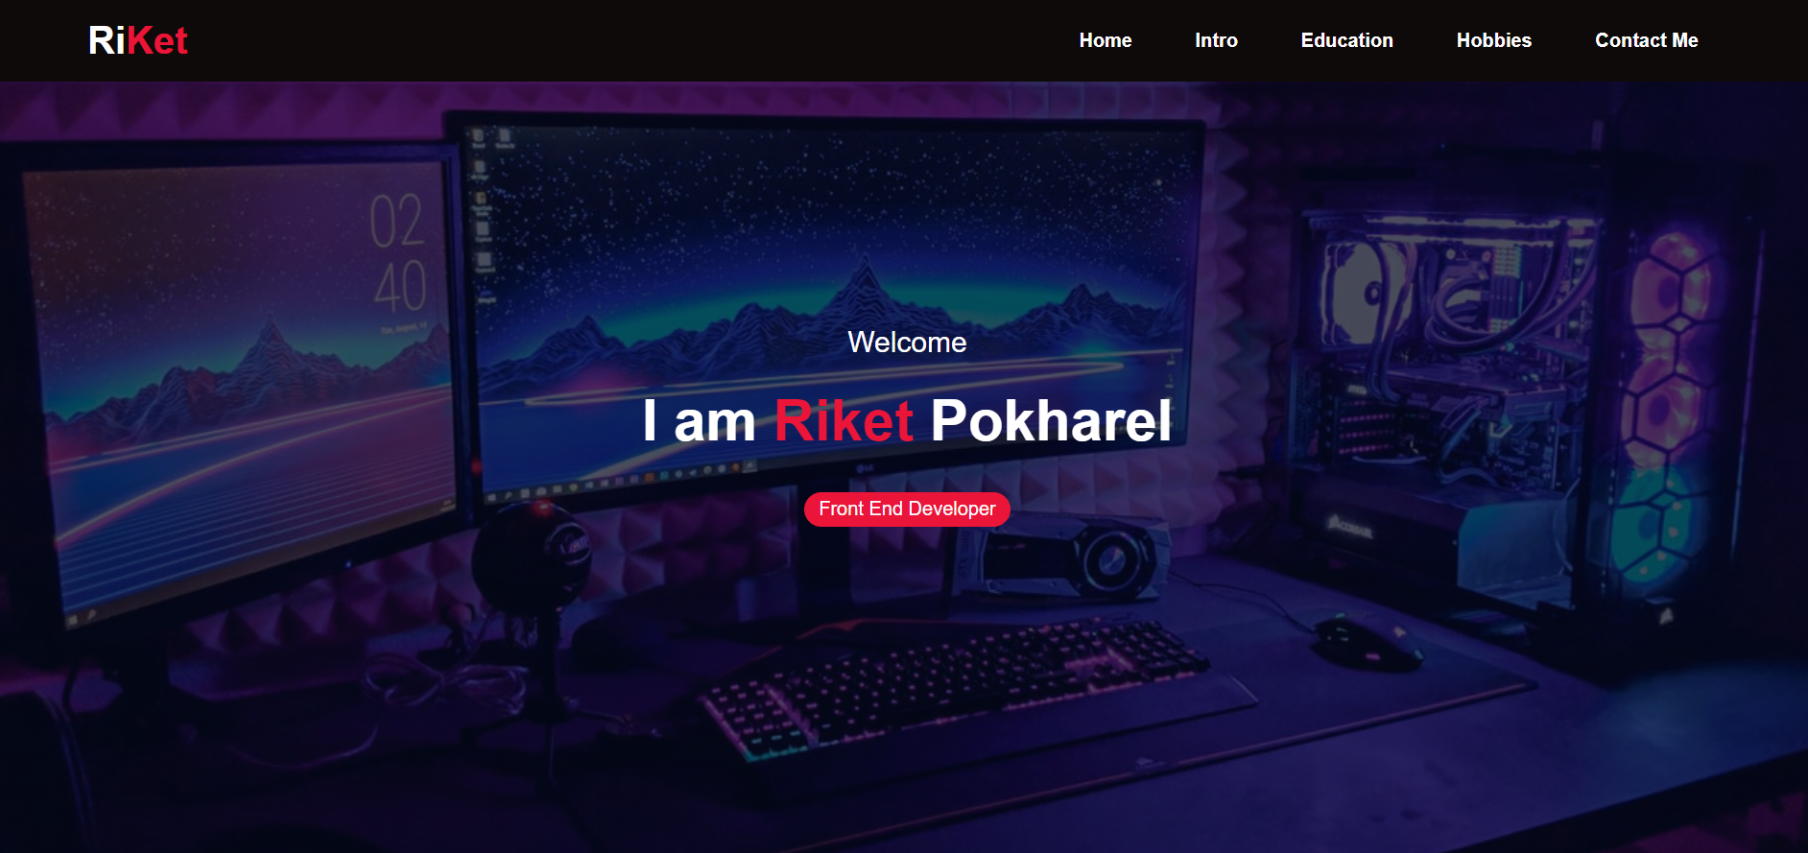

This is the homepage of my website. In this section, I have used HTML, CSS, and JavaScript. There is one text logo in the top left corner and navbars in the top right corners. The navbar is fixed. They all are inside into element nav. I have used flexbox. There I have also used background image. I have also added some texts over the image which are centralized. I have also used some JavaScript in this block. When this page is displayed in mobile view and clicked on the menu icon it will show the navbar and then clicking on the cross closes the navbar. The pages are linked to each other. If you click on Education, it will take you to the education section and it is the same for other options too. I have also used animation here for the text over the image using JavaScript aos.

1. **Intro**

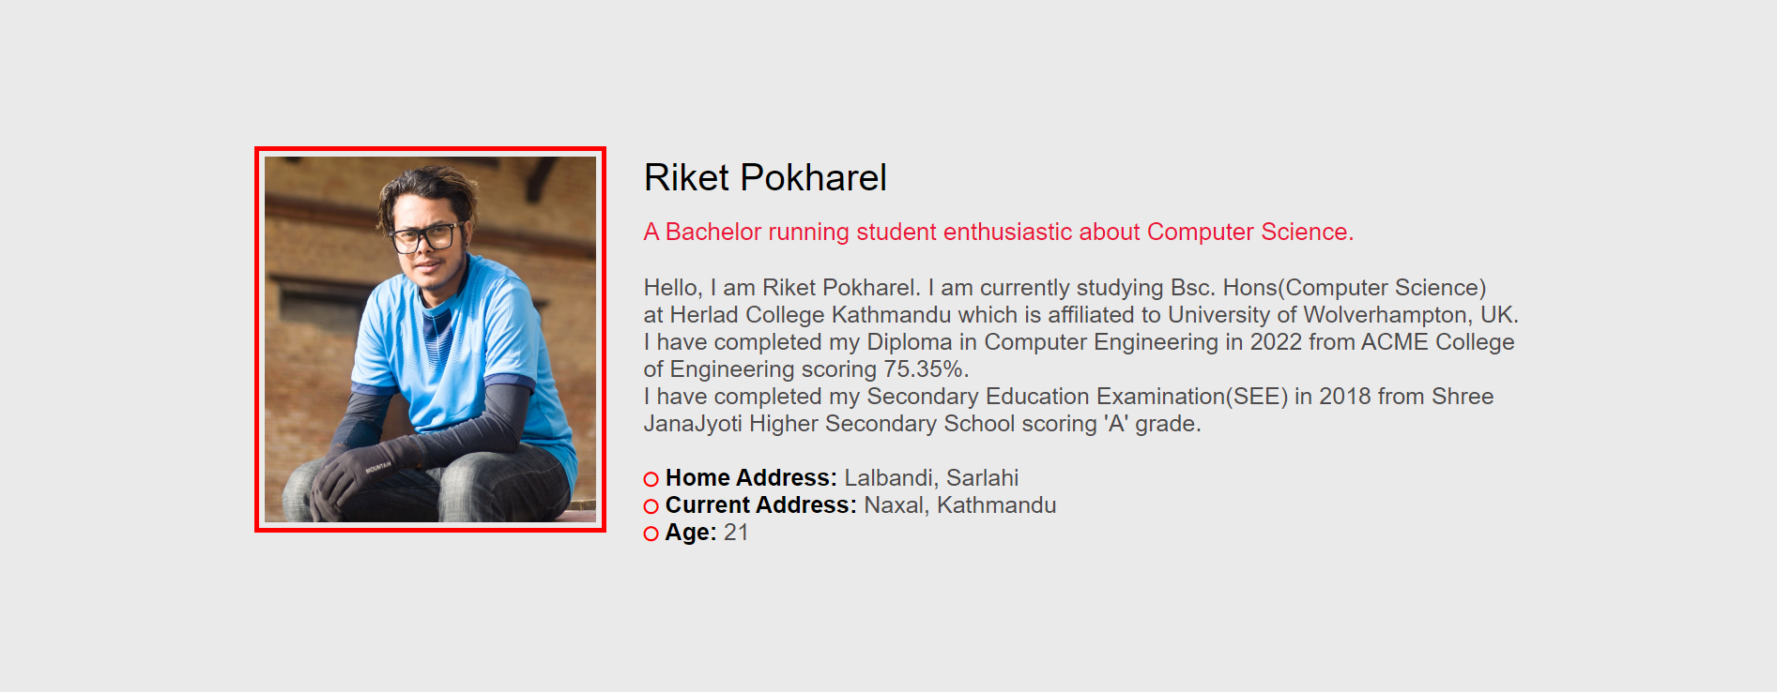

In this section, I have used <div> and inside that <div> there are two other <div> with the same class name. There is one image on the left-hand side and text and paragraphs on the right-hand side. I have used display: flex in the main div. I have also used animation in this portion. This section is also fully responsive.

1. **Education**

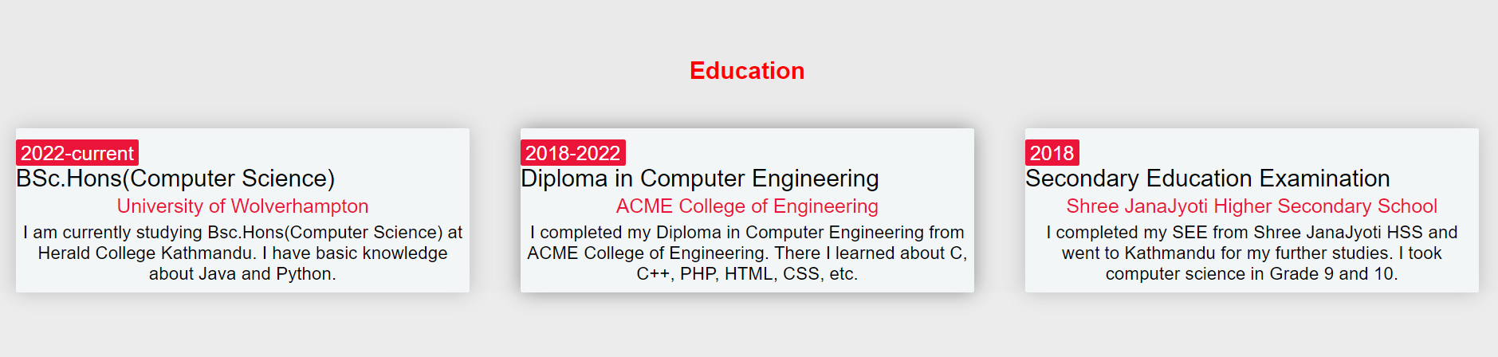

In this section, I have three <div> and I have again used flexbox here as it is one of the best CSS codes to justify contents properly. I have used <span> which is used to beautify the contents inside a block. The background color of the div is different from the webpage’s background color. I have also used ‘fade-up’ animation here. This section is also fully responsive.

1. **Hobbies**

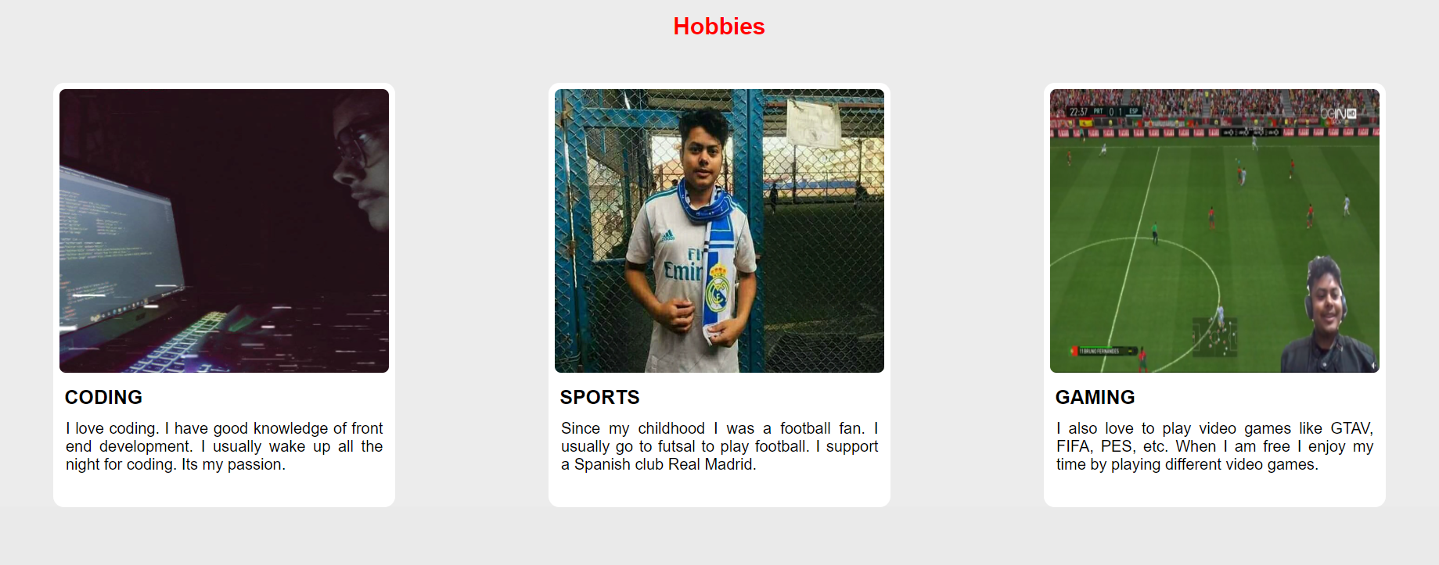

In this section, I have applied the same flexbox concept. But this <section> is a little different from the other section as it has a different background color and there are used different images and texts. I have used hover over that image and when you move the cursor over the image will have some moments. I have used ‘zoom-in’ animation in this section. This page is also fully responsive and I have used the flex-direction: column in the @media query.

1. **Contact me**

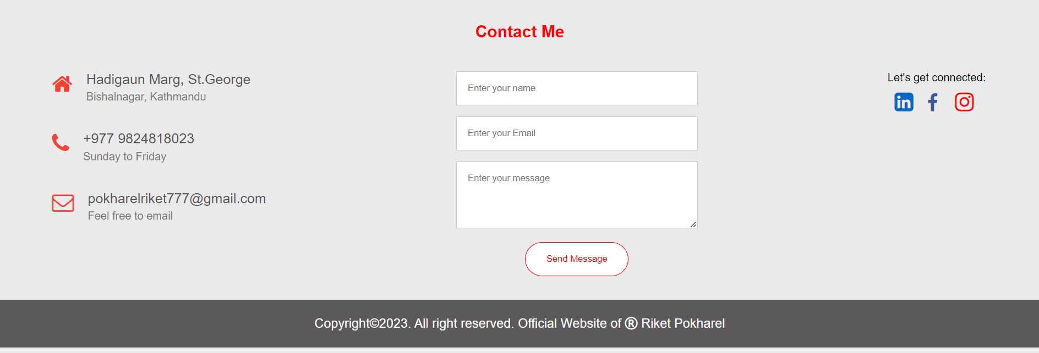

This is the footer part of my website. This is also fully responsive. On the left side, I have used different icons for home, phone, and envelop and there I have used a map link in the home part which will lead you to the location of my home. In the phone number, I have used tel: my number so that if you click there it will call on my number. Same as I have used mailto: my mail, so it will automatically lead to my mail where you can mail me. On the central part, there is a contact form where all the fields are required i.e., you have to fill all the forms else you won’t be able to send a message. On the right side, I have given all of my social media links with the target: “_blank” so the social media links will be opened in a new tab. And on the bottom of the page, I have used the copyright portion with a black background.